**Configuration – Administrative, Product Setup**  
Bug Report

Cycle 2

Afrida Rahman

Last Executed: 03/06/2024

**Product Setup**:

* Asset Product
* Change Asset Product
* Liability Product
* Change Liability Product
* Product Authorization

**Asset Product**

1. The option for selecting bars should be big for more visibility.

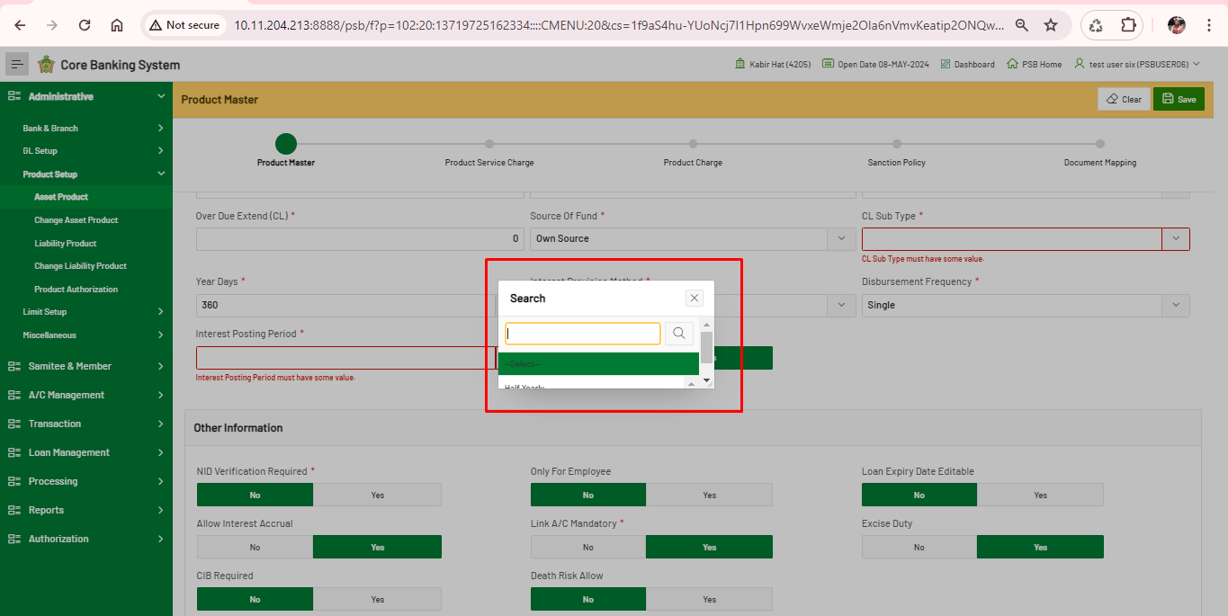

1. Saving form page don’t allow to go the Next page.

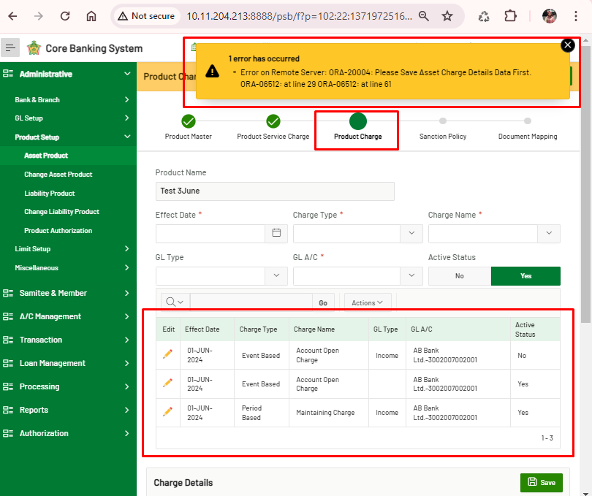

1. Incomplete account registration from “Asset Product” should not be in “Product Authorization” module.

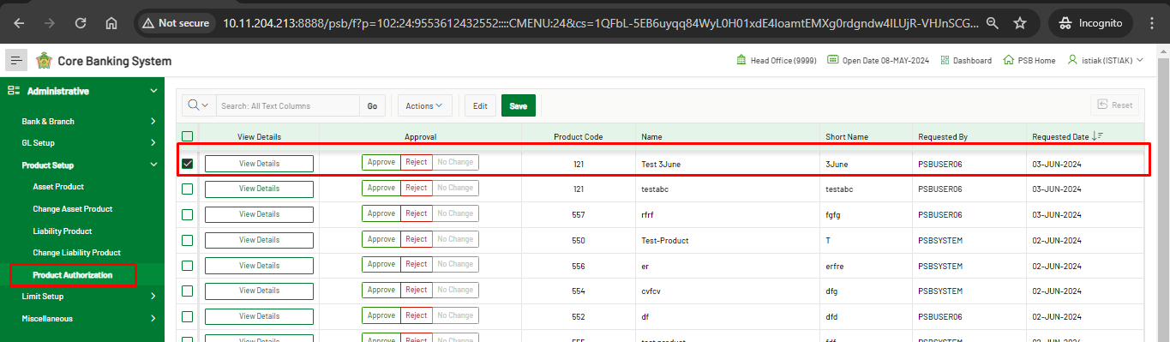 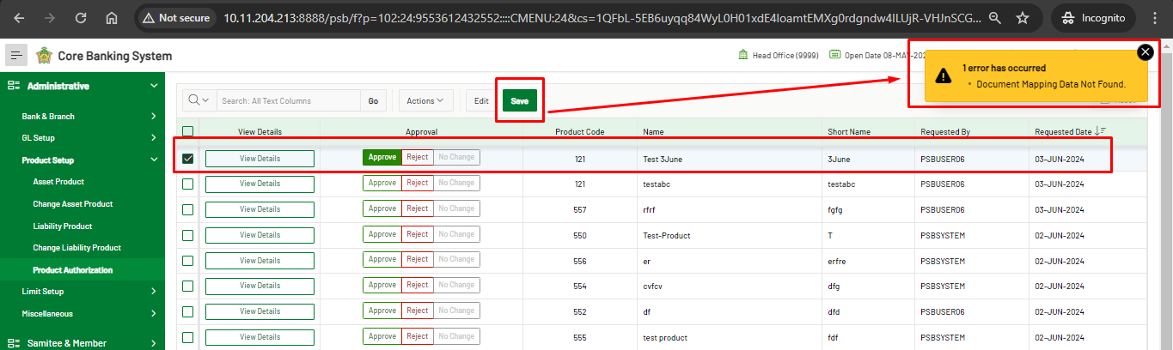

1. Error showing in Asset Product – Document Mapping form.

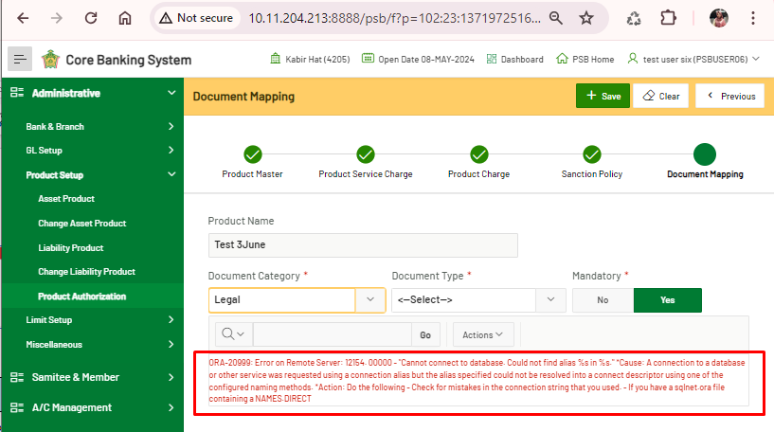

1. Mismatch between SRS and the System. “Submit” button should be added, instead of “+Save” button.

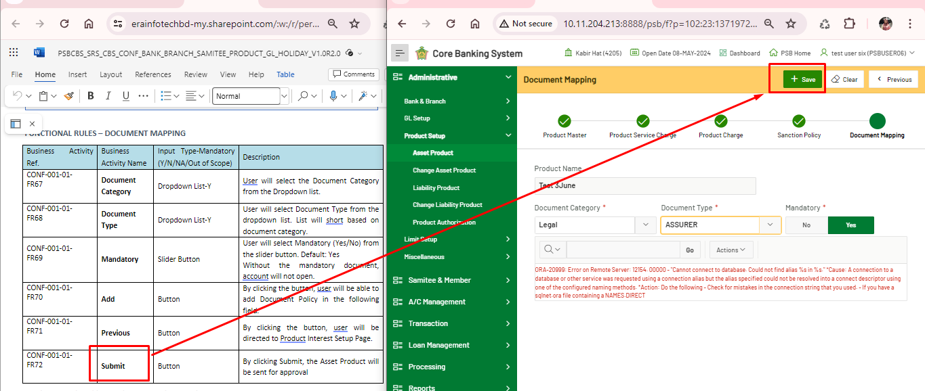

1. Mismatch between SRS and the System. There's no Add button to submit documents.

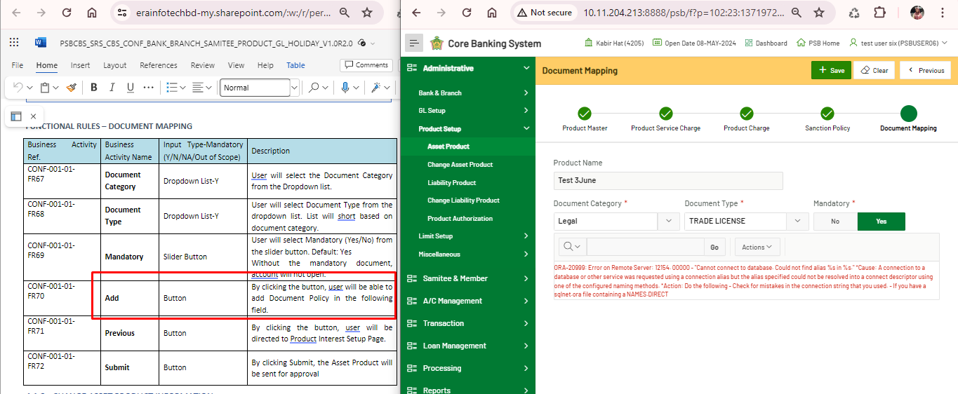

**Product Authentication**

1. Showing error in “Approve” product. A product from “Asset Product” product, whenever trying to Approve the product it shows error: “Product Sanction Policy Data Insert Problem.”

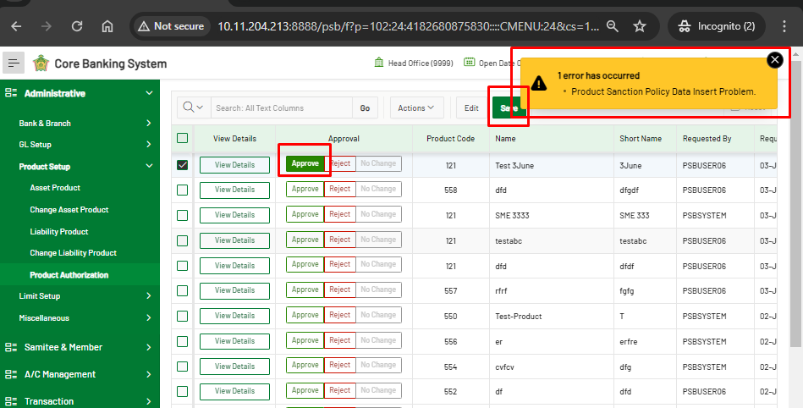

**Liability Product**

1. Saving form page don’t allow to go the Next page.

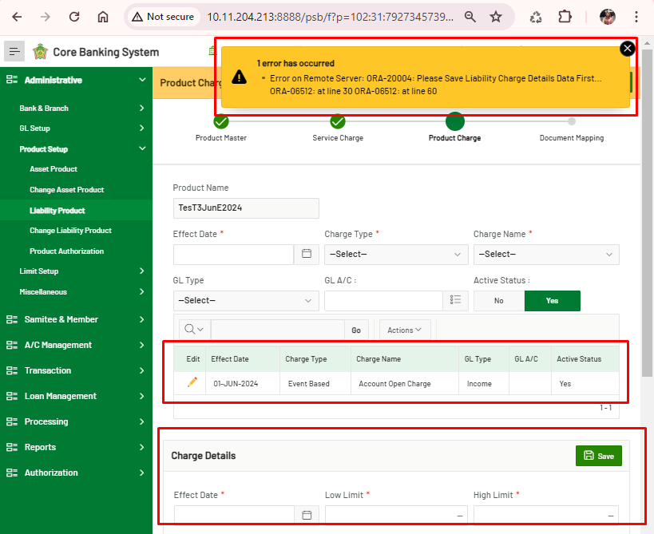

1. Error message shows wrong message.

For example, here Low limit = 2, High limit=100

If Higher limit => 10; json error give wrong message too.

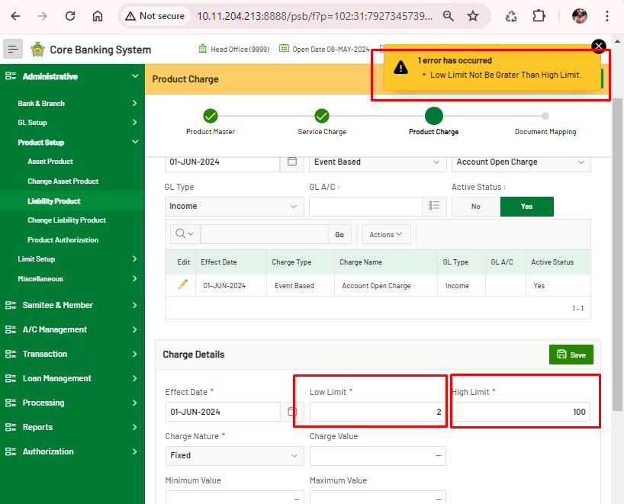

**Change Liability Product**

1. Error showing in Change Liability Product. “Core API Calling Problem”

